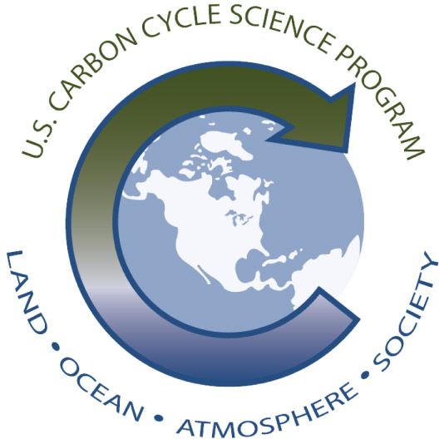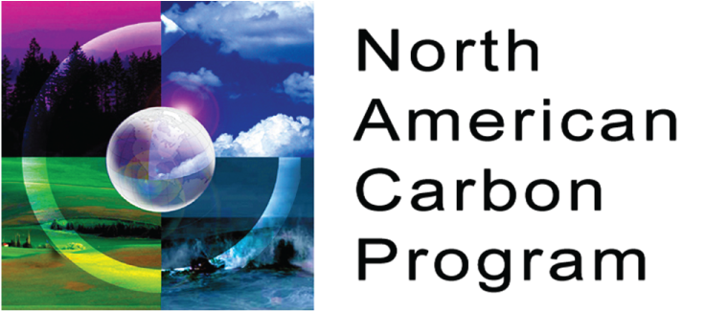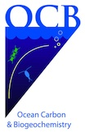

An Interdisciplinary Science Plan for
North American Coastal Carbon Research

Introduction

- History – scientific and programmatic context (NACM, US Carbon Cycle Science Plan)
- Overview of the NACP/OCB Coastal Synthesis activities
- Relevant international activities (IMBER-LOICZ workshop and continental margins task team, Liu et al., 2010)
- Mechanisms to support cross-disciplinary and international (Mexico, Canada) collaboration

Overarching Science Questions

- What changes can we expect in the coastal carbon cycle and associated ecosystems in the face of accelerating global change?

- How do carbon fluxes in the coastal zone help us reconcile land and ocean carbon budgets?

North American Coastal Regions

Coastal synthesis outcomes, regional budgets and remaining gaps
- Gulf of Mexico
- East coast
- West coast
- Great Lakes
- Arctic

Coastal Fluxes and Processes

Note: The bullet points in this and the following sections are not meant to be prescriptive. Rather, they represent outcomes and recommendations of regional synthesis activities to date, and can hopefully provide fodder for discussion during the breakout sessions.

Air-sea exchange – Are the coastal oceans of North America a net source or sink for atmospheric CO₂? What are the dominant physical and biogeochemical controls on the CO₂ source and sink terms?
- Gas (CO₂, CH₄, CO) and rainwater fluxes in estuaries, tidal wetlands, and coastal waters
  - Increased observational (pCO₂) coverage
  - Development and improvement of satellite algorithms and models for extrapolating in space and time
  - Coastal gas transfer coefficient parameterizations
  - More aerosol and rainwater measurements

Terrestrial inputs – What is the net transfer of carbon between land and coastal oceans?
- River input (inorganic and organic carbon, nutrients (N, P)), submarine groundwater discharge (SGD)
- Need DIC loading estimates from SPARROW
- Comparison across different models (SPARROW, Global NEWS, DLEM, etc.) and with observations
- Development of water budgets for biggest coastal aquifers
- More estimates of deep, recirculated marine SGD

Estuarine and tidal wetland fluxes – How is carbon transformed in estuarine and tidal wetland systems and how does this impact land-ocean fluxes?
- Lability and photoreactivity of POM and DOM derived from wetland and watershed sources
- Carbon cycling dynamics in the lower rivers (below USGS gauging stations)
- Improving lateral flux estimates and/or tidal exchange of DIC, DOC, and POC from estuaries to the coastal ocean
- Improved coupled hydrodynamic-biogeochemical models that can resolve key carbon transformation and transport processes in these systems
- Intercomparison studies across different estuarine and wetland systems

Biological transformations – How is carbon transformed by organisms in coastal systems and what is the fate of this carbon (export to open ocean vs. burial)?
- Photosynthesis, respiration and remineralization, N₂ fixation, denitrification, carbon flux parameters (NEP, NCP), etc. in coastal and inland systems
- Weighting techniques to avoid regional/seasonal biasing in average primary production (PP) calculations
- Changes in community composition and plankton functional groups
- Benthic primary production measurements, including macro- and micro-algae, sea grass, etc.
- More pelagic and benthic respiration measurements (bottle incubation) and application of other techniques (O₂/Ar, satellite-based particle export) to better constrain coastal NCP
- Examination of archived satellite (ocean color) imagery to better quantify role of episodic events in biological carbon cycling

Carbon export and burial - How much carbon is buried in coastal ocean sediments?
- Sinking particle flux
- Burial and resuspension

Cross-shelf exchange – What is the net transfer of carbon between coastal and open oceans?
- Lateral transport
- Physical features (currents, gyres, eddies, etc.) and defining a non-stationary ocean boundary
- Approaches: Numerical models, tracer-based approaches, event-scale process studies (10s kms, days to weeks)

Coastal Observations and Monitoring
Identify highest priority observations for key processes and fluxes above, including regionally specific recommendations

Considerations:
- Leverage what already exists – OOI, coastal moorings, buoys, floats, gliders, repeat coastal surveys and time-series (CalCOFI, etc.)
- Shipboard measurements
- Autonomous measurements (including sensor development)
- Satellite remote sensing data (ocean color, salinity, etc.)
- More routine and efficient use of continuous, flow-through technology at sea (nutrients, carbonate system parameters, etc.)
- Dedicated measurement campaigns in estuaries and tidal wetlands

Coastal Modeling, Synthesis, and Data Assimilation
Recommend integrated data and modeling approaches for working within and across the land-ocean continuum

Considerations:
- Continued synthesis and mining of carbon flux data (e.g., long-term time-series) and centralized coastal carbon data repository
- Models to inform observations/sampling – e.g., Observing System Simulation Experiment (OSSE)?
- Development of statistical/modeling techniques to utilize satellite-based and other high-resolution data sets to scale up local carbon flux estimates
- Continued development and improvement of mechanistic numerical models at the appropriate scale for studies of the coastal carbon cycle (i.e. 10s of km)
- Model-model and model-data intercomparison studies
- Comparisons of independent estimates of same fluxes

