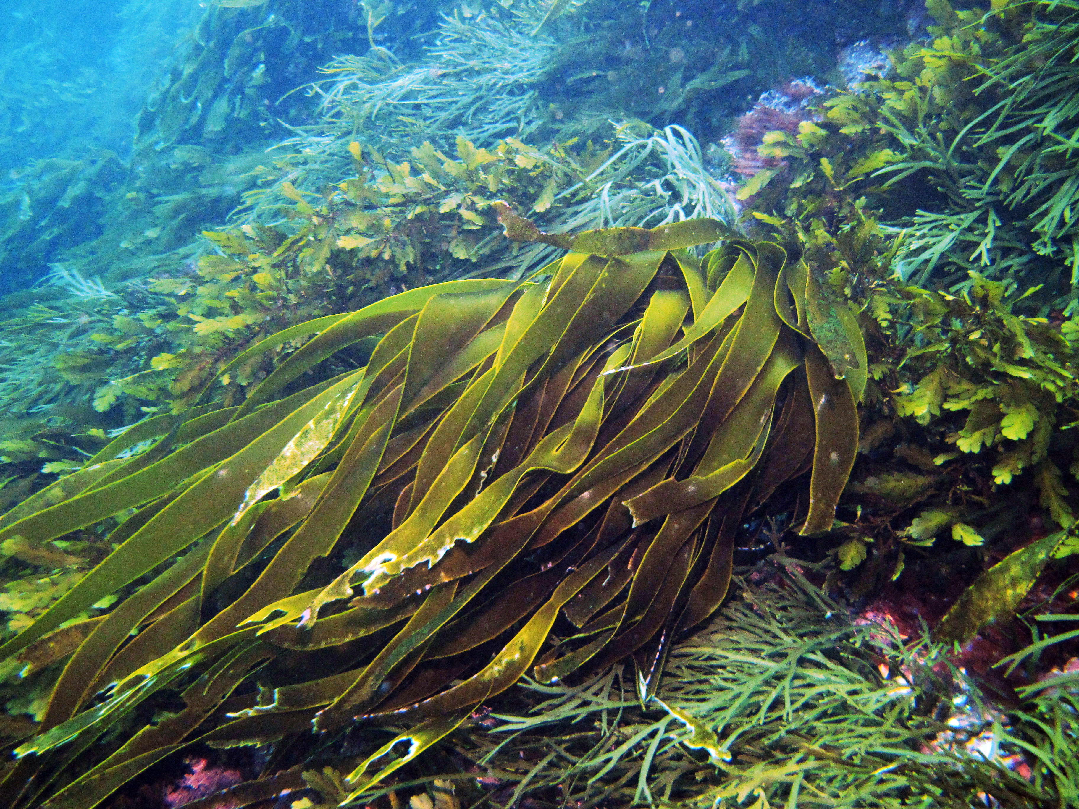
Image courtesy of NIWA
Even with Paris carbon emission-reduction commitments the world is facing an average 3.5°C temperature rise. The promotion of kelp-derived blue carbon sequestration is emerging as an exciting opportunity to ameliorate climate change. This project will test the sequestration potential of kelp in the Aotearoa New Zealand context, where rich kelp beds and adjacent deep submarine canyons provide a unique ability to produce kelp biomass that can be exported to the deep sea.
You will be part of a project aiming to quantify the accumulation of kelp-derived carbon in deep-sea environments in the vicinity of natural kelp beds. This will be achieved using a range of techniques; stable isotope biomarkers as well as environmental DNA (eDNA), combined with radiocarbon dating and data on sediment-laden flows and accumulation rates. Kelp degradation experiments will be conducted to test the applicability of molecular and isotopic tools for identifying and quantifying kelp carbon contributions to marine sediments. By determining carbon concentrations, age and biological source, this project will establish for the first time, a relationship between coastal kelp-biomass and the quantity and longevity of kelp-derived carbon sequestration in offshore sediments.
This scholarship is fully funded by a MBIE Smart Ideas grant through Blue Carbon Services Ltd, the National Institute of Water and Atmospheric Research (NIWA) and Victoria University of Wellington. The scholarship includes tuition, a stipend and covers research costs for 3 years. The successful applicant will share their time between the NIWA campus at Greta Point (Wellington) and VUW.
Key attributes/skills/qualifications that are required: 1) Master’s degree or an equivalent in a related discipline; 2) experience in molecular biology and some bioinformatic analysis; 3) IELTS overall band of 6.5 (not required if your degree is from a country where English is the first language); 4) ability to communicate clearly and work as part of a team. Experience working with macroalgae would be an advantage but is not essential. Holding of a current driving licence (or the ability to obtain a driving license) valid for use in New Zealand would be an advantage.
Applications in the first instance should be made directly to Prof Joe Zuccarello (joe.zuccarello@vuw.ac.nz) by December 15th 2021 (or sooner) and include a cover letter outlining why you want the PhD position (really important), full CV, academic transcripts, an example of your scientific writing, and the names/contact details of two people who can act as academic references (there is no need to request any reference letters be sent at this stage).

